Connected Component Analysis Of Bengali Character
Recognition.
Pritilata Biswas^{1*}, Sumaia Afrin Prity², Parvez Abedin Siddique³ , Arifa Islam Champa⁴
- Student, Dept of Computer Science And Engineering
Bangladesh Army International University Of Science And Technology, Cumilla, Bangladesh
Email : pritilata.biswas66@gmail.com tel : +8801923388240
- Student, Dept of Computer Science And Engineering
Bangladesh Army International University Of Science And Technology, Cumilla, Bangladesh
- Student, Dept of Computer Science And Engineering
Bangladesh Army International University Of Science And Technology, Cumilla, Bangladesh
- Lecturar, Dept of Computer Science And Engineering
Bangladesh Army International University Of Science And Technology, Cumilla, Bangladesh

Abstract
Bangla handwritten character recognition (HBCR) is becoming an important issue in several years but it becomes a challenge to get good performance due to the segmentation and many of them are similar. It remains largely unsolved due to the presence of many ambiguous handwritten characters and excessively cursive Bangla handwriting. Even many advanced existing methods do not lead to satisfactory performance in practice that related to HBCR. In this paper, we mainly focused on the segmentation process which is the backbone of the recognition phase. At the preprocessing part, the input image is processed by using various filters for getting the binary image. Then for segmentation purposes, horizontal projection profile (HPP) and vertical projection profile (VPP) are used. As Bengali words are connected through Matra line, by removing them, characters get topologically disconnected.

Keywords- Bengali character, Image processing, Segmentation, Horizontal Projection Profile (HPP), Vertical Projection Profile (VPP).

- Introduction:
Segmentation of Bangla handwritten text is the pre-process of handwritten text. The Bengali script is also used for representing other languages like Meithei and Bishnupriya Manipuri, and there is a time when it used to write Sanskrit within Bengal [1]. Most of the Bengali characters are topologically connected [2]. They can be easily classified using this connectedness property. This classifying or segmentation of the Bengali character is the most challenging task in making a Bengali Optical Character Recognition (OCR). In Bengali, there is a combination of basic, modified and compound characters. The combination of characters can be more than 300. Here, Bengali character segmentation is the most challenging task. So, we need some robust techniques that can classify these compound characters.
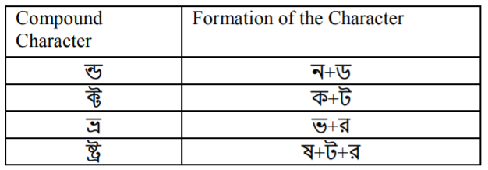
Table 1: Some compound characters in the Bengali script [2].
As we know Bengali script characters are connected with a Matra line, so the characters can be easily recognized by the connected component analysis [2]. In this paper, our main contribution is to improvise the method of analyzing connected components using some common image processing operations.

2. Segmentation Process
Zahan at el [2], the following step by step process is proposed that is mainly based on the segmentation process.
  - Pre-Processing:
In this step, a general image is taken as input at a minimum resolution of 100 dpi and a maximum resolution of 300 dpi. Here the image is also checked for skew angle [3].
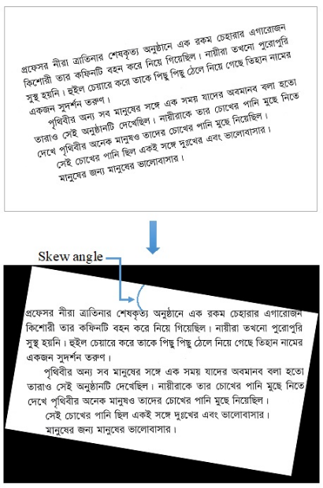

Figure 1: skewed Bangla printed text (at the top) and corrected skew (at the bottom) [2].
  - Line Segmentation:
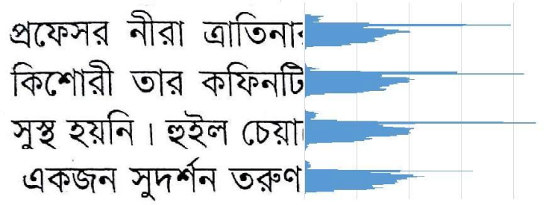
The lines are segmented using a horizontal projection profile by finding the horizontal pixel gap.
Figure 2: Line segmentation process [2].
  - Word Segmentation:
The words are segmented using a vertical projection profile by finding the vertical pixel gap.
Figure 3: Word Segmentation [2].
  - Character segmentation:
The characters are segmented by Matra line detection.
Figure 4: Segmented Characters [2].
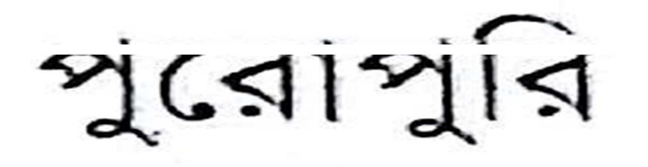
Matra line detection: The overall accuracy is depending on this particular operation. It is done by horizontal profile projection [4].
figure 5: disconnected characters after Matra line detection [2].
There is a big drawback in this method that is if we remove Matra line some characters like গ, ণ, শ will change [2].

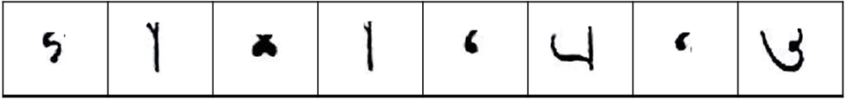

Figure 6: Characters split into two parts [2].

3. Other Operations
Closing: Closing is Dilation followed by Erosion. It removes small holes in the foreground, changing small islands of background into the foreground. This technique can also be used to find specific shapes in an image.[5]
Dilation and Erosion: Dilation adds pixels to the boundaries of objects in an image, while erosion removes pixels on object boundaries. The number of pixels added or removed from the objects in an image depends on the size and shape of the structuring element used to process the image.[6]
4. Methodology
A typical OCR system consists of preprocessing, segmentation, recognition and post-processing parts. In this paper, we mainly focused on the segmentation process which is the backbone of the recognition phase.
At first, the input image will be converted into a grayscale image using a grayscale filter and using a bilateral filter we will remove the noise in the input image. Then using bit plane slicing the input image will be binarized and will be converted into a two-tone image. Some input images may be skewed by a few degrees. For skew correction, we will use the skew angle technique [3].
In the Bengali script, lines are almost of the same height. There is a horizontal gap between the two lines. We will detect those gapes by horizontal projection profile (HPP). Vertical projection profile (VPP) will be used in word segmentation from extracted lines. In this process, the number of black pixels in each column will be calculated. In a vertical scan, if no black pixel found then it will be considered as the gap between words.
Bengali words are connected through the Matra line. By removing them, characters get topologically disconnected. Then using the connected component method, individual components of a word can be separated. And then we will apply erosion and dilation to remove the problems that will occur from the removal of Matra line.

5. Results
While character segmentation, when the matra line removal process is applied then the Bengali character will be split out. Then the output will look alike the following figure:
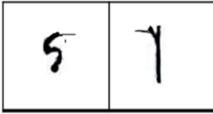
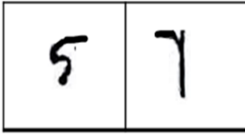
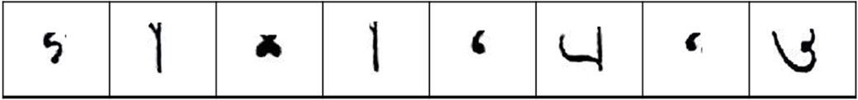
- (b) (c)

Figure 7: (a) Current output which occurs problem [2]
(b) After closing the expected output [5]
(c) Dilation on (b) [6]

6. Discussion:
The overall process is based on segmentation for the Bengali character. For the segmentation process, Line segmentation, Word segmentation, Character segmentation are applied respectively. Character segmentation is the most difficult part of the overall segmentation process. Bengali characters are connected through the matra line and the overall accuracy of the segmentation process is mostly dependent on the proper detection of the matra line. As it is the core component of character segmentation so removing the matra line is the most challenging part.

7. Conclusion:
  - Main challenge:
Removing the matra line from the characters properly
7.2 Limitations:
Might increase the cost of the algorithm
The connected component might not be regenerated as per expected output

8. References
- https://en.wikipedia.org/wiki/Bengali_alphabet
- T. Zahan, M.R. Selim, M.S. Rahman, M.Z. Iqbal, (2018). “Connected Component Analysis Based Two Zone Approach for Bangla Character Segmentation.” 1-4. 10.1109/ICBSLP.2018.8554684.
- M. A. Obaida, T. K. Roy, M. A. Horaira and M. J. Hossain, “Skew Correction Function of OCR: Stroke-Whitespace based Algorithmic Approach,” International Journal of Computer Applications 28(8):7-12, August 2011.
- S. S. Goswami, “Identification of Matra Region and Overlapping Characters for OCR of Printed Bengali Scripts,” Intelligent Computing and Information Science, Volume 135 of the series Communications in Computer and Information Science, pp. 606-612, 2011
- https://homepages.inf.ed.ac.uk/rbf/HIPR2/close.html
- https://docs.opencv.org/2.4/doc/tutorials/imgproc/erosion_dilatation/erosion_dilatation.html
- B. B. Chaudhuri and U. Pal, “A Complete Printed Bangla OCR System,” Pattern Recognition, Vol. 31, No. 5, pp. 531—549, 1998.
- J. U. Mahmud, M. F. Raihan and C. M. Rahman, “A complete OCR system for continuous Bengali characters,” In Proceedings of the TENCON, 1372–1376, 2003.
- S. M. M. Mahmud, N. Shahriar, A.S.M D. Hossain, M. T. M. Chowdhury, and M.A. Sattar, “An Efficient Segmentation Scheme for the Recognition of Printed Bangla characters,” Proceedings of ICCIT, pp 283-286, 2003.
- M. A. M. Hasan, M. A. Alim, and M. W. Islam “A New Approach to Bangla Text Extraction and Recognition from Textual Image”, Proceedings of ICCIT, 2005.
- https://www.abbyy.com/. Last accessed 07 Dec 2016

